Notes for Kevin 20180828

Exploring the “test job” on Quantius with crosshair and polygon annotations

I've been exploring the portal and these are my initial thoughts.

My first observation was that the image shown is quite small.

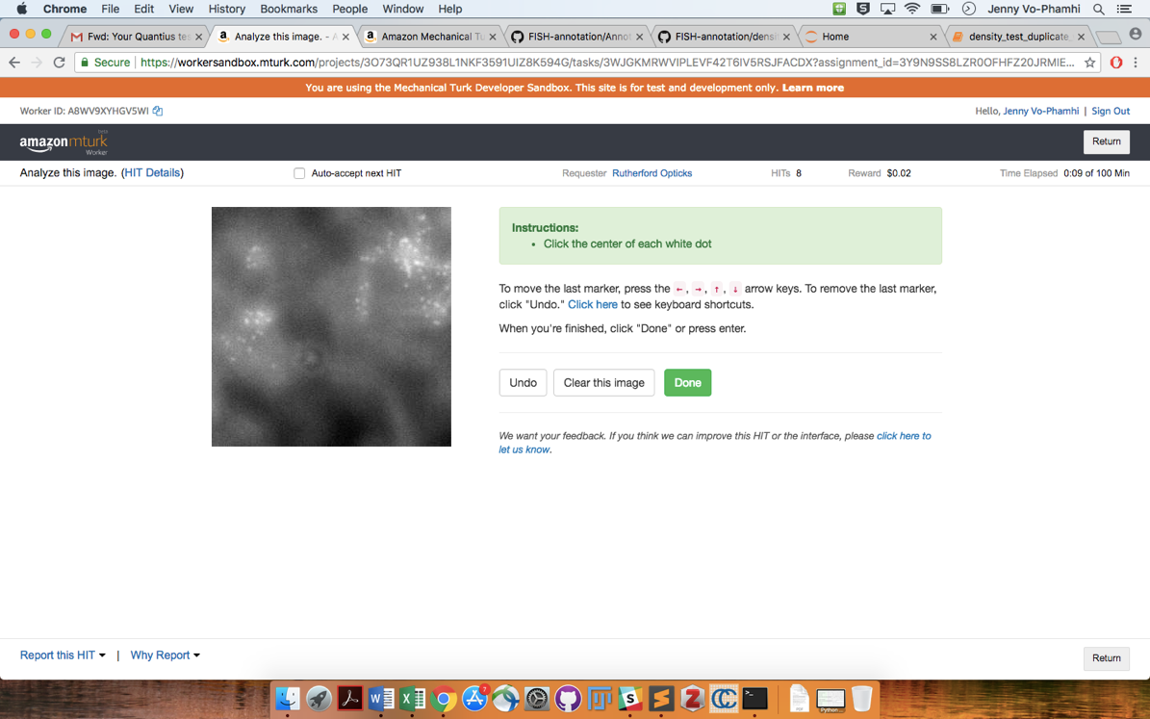

It does scale up when I use my desktop monitor, in proportion with screen size, which helps a little. On this page, I couldn't zoom in with two-finger zoom, but I could zoom in using Command+plus sign, which made it a lot easier to aim the cursor.

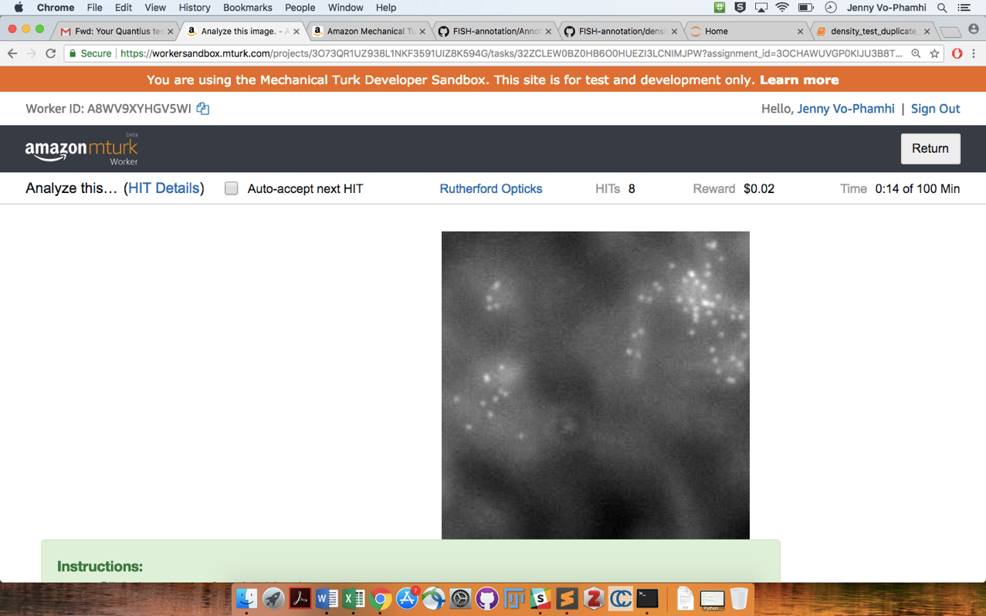

Not sure how many workers would actually take the step to figure out how to zoom in and then zoom in.

Something else I noticed is that relative to the spots, the crosshairs left on the image are quite large.

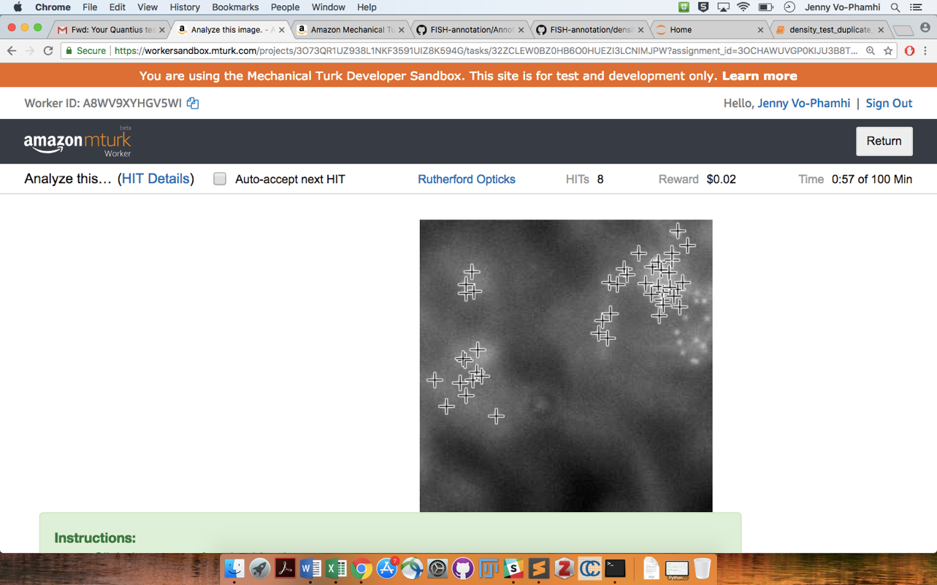

Especially in dense areas, the crosshairs left on the image sometimes obstruct spots that haven't yet been annotated.

The polygonal annotations are executed by clicking for the vertices of a polygon and then clicking to close the polygon. The markers for the vertices are about the same size as the spots.

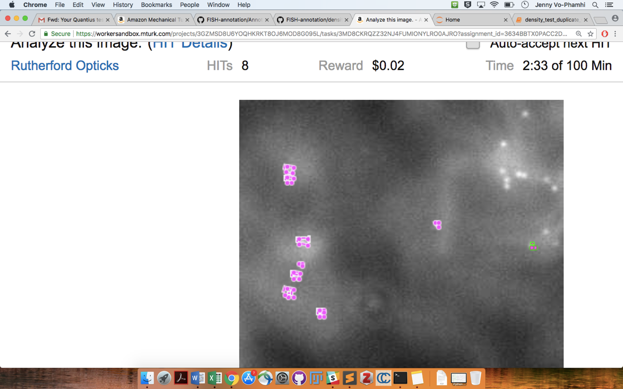

This makes annotating especially difficult in dense areas, where these pink vertex markers obstruct neighboring spots and even the spot itself. May I'm just not very good at this, but I often found myself accidentally closing a polygon too early and having to scroll down to find the "undo" button. Sometimes, as in the previous image (pink and green clump), it's hard to tell where the polygon started. I would be interested to know how many workers would be willing to put in the effort to polygonally annotate a lot of spots. It's even harder if the worker doesn't zoom in.

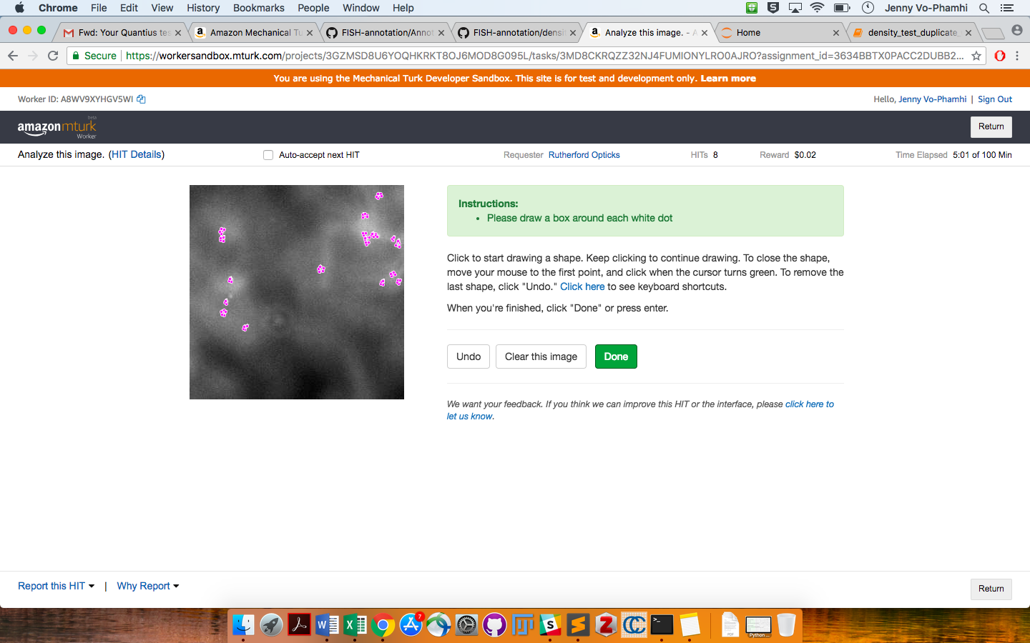

I did complete a set of eight annotations with clicks and crosshairs and I copied down my Worker ID in case we want to see how well I did as an individual motivated to get good clicks. I am interested in the format in which the polygonal annotations will be sent to us. I'm guessing the annotation ingestion and analysis classes would need additions to accommodate the new data format. I think the existing descriptions for the tasks are very clear. I have enough annotations to work with for now, but perhaps for future experiments, we can add a sentence or two about how to zoom on a Mac or PC.